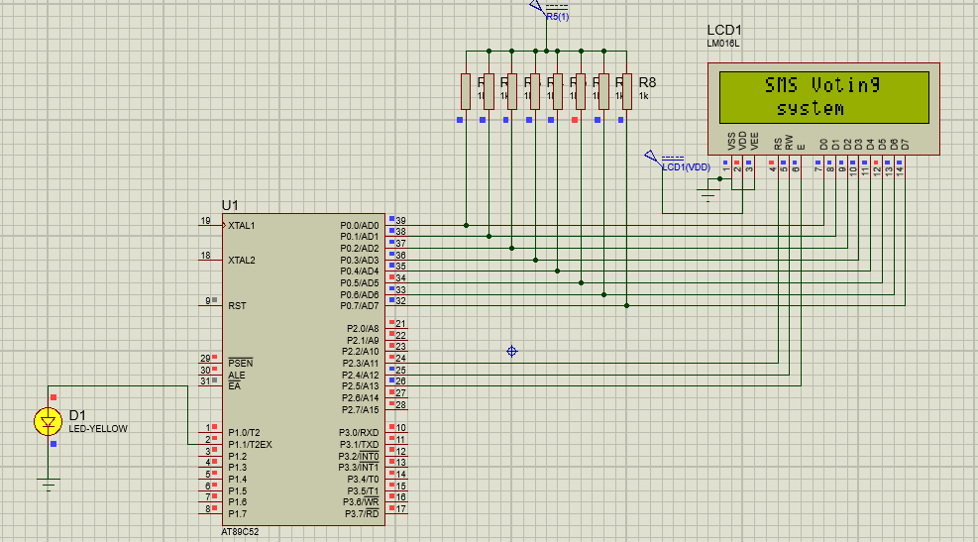

SMS VOTING SYSTEM PROTEUS